CRYPTOGRAPHY AND NETWORK SECURITY LAB
(Course Code: 23UPCSC1E14)

A laboratory record submitted to Periyar University, Salem In partial fulfillment of the requirements for the degree of

MASTER OF COMPUTER APPLICATION
By

ANITHA J
[Reg. No: U25PG507CAP004]


DEPARTMENT OF COMPUTER SCIENCE PERIYAR UNIVERSITY
(NAAC`A++`Grade with SDG Institutions Rank Band: 11-50)

State University NIRF RANK 94 – State Public University Rank 40

SALEM – 636 011.
(APRIL - 2026)

CERTIFICATE

This is to certify that the Programming Laboratory entitled “CRYPTOGRAPHY AND NETWORK SECURITY LAB (23UPCSC1E14)”
is a bonafide record work done by Mr. /Ms. Register No:
as partial fulfillment of the requirements for the degree of Master of Computer Application, in the Department of Computer Science, Periyar University, Salem, during the Academic Year 2025-2026.

Staff In-charge Head of the Department

Submitted for the practical examination held on……...………………

Internal Examiner External Examiner

CONTENTS
S.NO | DATE | TITLE OF THE PROGRAM | PAGE NO | SIGNATURE
1. |  | XOR Operation on a String with Zero
2. |  | Write a program to perform encryption and decryption using the Ceaser Cipher
3. |  | Write a program to perform encryption and decryption using the Hill Cipher
4. |  | Write a program to perform encryption and decryption using the Vernam Cipher
5. |  | Write a program to perform encryption and decryption using the Substitution Cipher
6. |  | Write a program to perform encryption and decryption using the DES algorithm
7. |  | Write a program to implement hash function using SHA algorithm
8. |  | Connect to switch with a computer and enable the port security
9. |  | Implement signature scheme – Digital Signature Standard
10. |  | Identify and capture the user name and password in a same network using wireshark

OUTPUT:

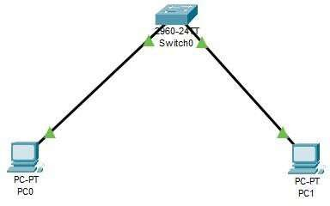

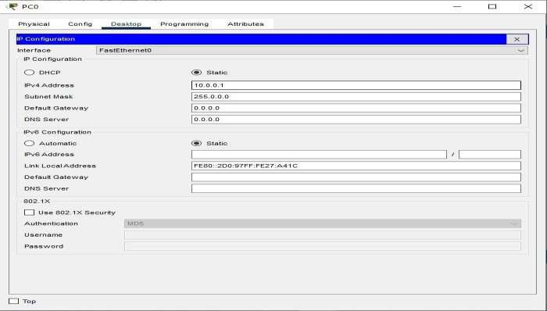

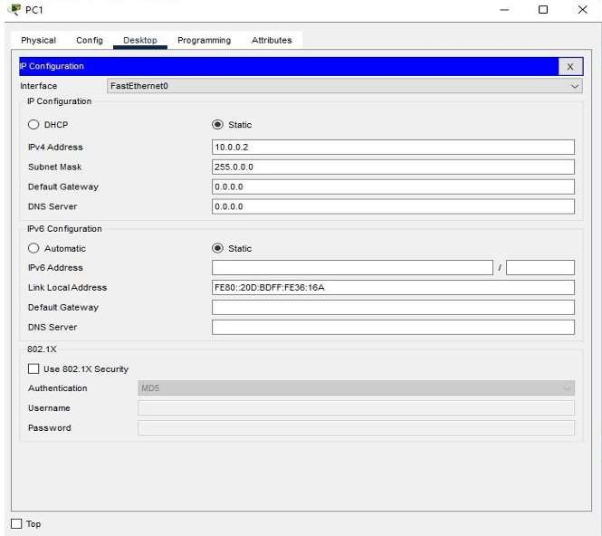

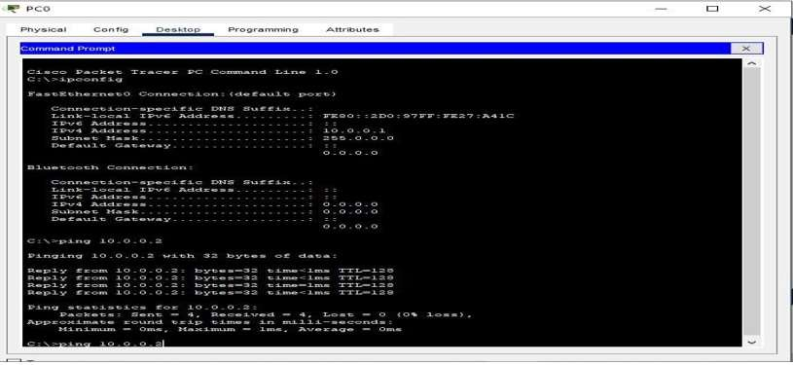

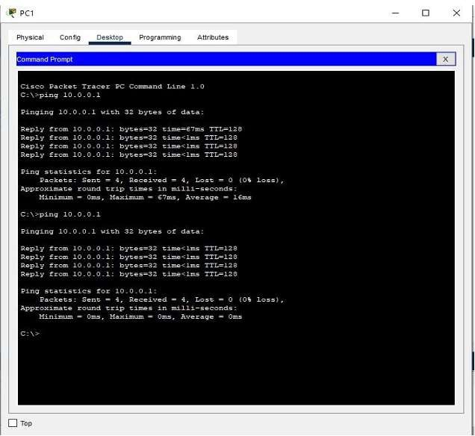

- Switch#enable
- Switch#show ip interface brief
- Switch#show port-security
- Switch#show port-security address
- Switch#show mac-address-table

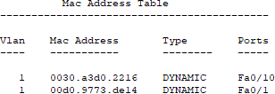

- Switch#configure terminal
- Switch(config)#interface fastEthernet 0/2
- Switch(config-if)#switchport mode access
- Switch(config-if)#switchport port-security
- Switch(config-if)#switchport port-security mac-address ?
- Switch(config-if)#switchport port-security mac-address sticky
- Switch(config-if)#switchport port-security maximum ?
- Switch(config-if)#switchport port-security maximum 1
- Switch(config-if)#switchport port-security violation ?
- Switch(config-if)#switchport port-security violation
- Switch(config-if)#switchport port-security violation shutdown
- Switch(config-if)#^Z
- Switch#show port-security

- Switch#show port-security address
- Go to PC2 command prompt and enter the below thecommand
  - ping 10.0.0.1

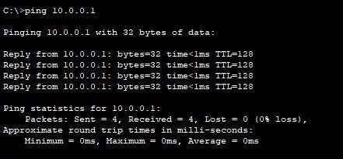

- After go to the Switch CLI
- Switch#show port-security address

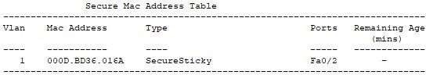
- Switch#show port-security

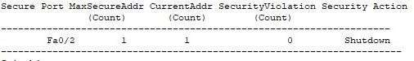

OUTPUT:

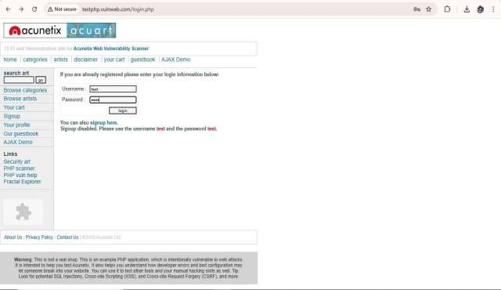

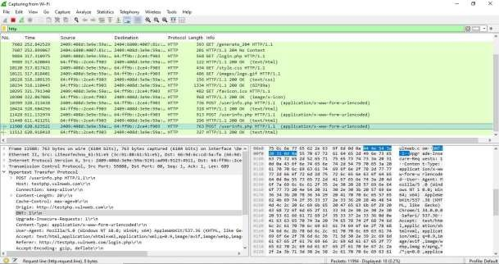

'3,CapturingfromWi-Fi
File Edit View Go Capture Analyze S.tatisti Telephony Wireless Tools Help
111-<S.® 181 '!Ga®"'ei°.ill. ee ll1.E1.E1.!1:5El
i'.I X

No. Time Source Destination Protoc::ol Length Info

+ 11512 52-0.918418 64:ff9b: :2ce:4:f903 2409:408d:3e:9e::59a: Mark/UnmarkSelected
+
7602 252.842529 | 2409:408d:3e9e:59a:_ 2404:6800:4007:Slc:_ HTTP | 393 GET /generate_204 HTTP/1.1
7607 252.899067 | 2404:6800:4007:81c:_ 2409:408d:3e9e:59a:_ HTTP | 201 HTTP/1.1 204 Ho Content
9884 317,31e975 | 2409:408d:3e:9e::5911:- 54:ff9b: :2ce:4:f903 HTTP | 568 GET /login.php HTTP/1.1
9989 317.620045 | 64:ff9b: :2ce4:f903 2409:408d:3e9e:59a:_ HTTP | 122 HTTP/1.1 200 QI( (teKt/ht11l)
10120 317.817421 | 2409:408d:3e:9e::59a:_ 64:ff9b::2ce:4:f903 HTTP | 434 GET /style:.css HTTP/1.1
10121 317.818401 | 2409:408d:3e9e:59a:_ 64:ff9b: :2ce4:f903 HTTP | 486 GET /images/logo. gif HTTP/1.1
10228 318.109135 | 64:ff9b: :2ce4:f903 2409:408d:3e9e:59a:_ HTTP | 156 HTTP/1.1 200 OK (teKt/css)
10234 318.110443 | 64:ff9b: :2ce:4:f903 2409:408d:3e:9e::59a:_ HTTP | 1334 HTTP/1.1 200 OK (GIF89a)
10295 321.791340 | 2409:408d:3e9e:59a:_ 64:ff9b::2ce4:f903 HTTP | 482 GET /favicon.ico HTTP/1.1
10300 322 .067086 | 64:ff9b: :2ce4:f903 2409:408d:3e9e:59a:_ HTTP | 968 HTTP/1.1 200 OK (image/K-icon)
10399 328. 313438 | 2409:408d:3e:9e::5911:_ 54:ff9b: :2ce:4:f903 HTTP | 736 POST /use:rinfo.php J-fTTP/1.1 (application/>e-www-form-urle:ncode:d)
10424 328. 604256 | 64:ff9b: :2ce4:f903 2409:408d:3e9e:59a:_ HTTP | 318 HTTP/1.1 200 QI( (teKt/ht:111)
11428 611.132974 | 2409:408d:3e:9e::59a:_ 64:ff9b::2ce:4:f903 HTTP | 913 POST /use:rinfo.php HTTP/1.1 (11pplic11tion/K-www-for-a-urle:ncode:d)
11440 511.421251 | 64:ff9b: :2ce4:f903 2409:408d:3e9e:59a:_ lfTTP | 296 HTTP/1.1 200 OK (teKt/html)
11508 620.623521 | 2409:408d:3e9e:59a:_ !64: ff9b: :2ce4: f903 | -,;1.1 (application/K-www-fon1-urlencoded

lgnore:/Unignore:Seleded Ctrl•D
)
html)

Host: testphp. vulnweb. cooi\r\n Connection: ke:e:p-alive:\r\n
> Conte:nt-Le:ngth: 20\r\n
Cache-Control: naK-age--0\r\n
Origin: http:/ /te:stphp. vulnwe:b. con\r\n D/H: 1\r\n
Upgriide-Insecure-Requests: 1\r\n
Content-Type:: application/x-w.l'W-form-ur le:ncoded\r \n
S.et/Unset1imeReference 1imeS.hift...
Packet Comment
I

EditRe:s.olve:dName:

Applya Filte:r Pre:pareasFilte:r
Ctrl•l Ctrl•Shift•T

66 9d 6c cd 5a fa 3c 91 80 61 51 e:5 86 dd 60 -ad
08 ba 02 c5 06 41 24 09 40 8d 3e 9e 05 9a 51 91
ad 98 91 23 45 11 00 64 ff 9b 00 00 00 oo 00 00
00 00 2c e4 fg 03 da 50 00 50 07 46 e7 c5 3a cc
f7 e:a 50 18 02 01 7c 7a 00 0-0 50 4f 53 54 20 2f
75 73 65 72 69 6e 66 6f 2e 70 68 70 20 48 54 54
50 2f 31 2e 31 0d 0a 48 6f 73 74 3a 20 74 65 73
74 70 68 70 2e: 76 75 6c 6e: 77 65 62 2e: 63 6f 6d
0d 0a 43 6f 6e: 6e 65 63 74 69 6f 6e: 3a 20 6b 65

f•l·Z·< ·11Q.. ·'
·A! @·> ·Q·
#!: ·d
- P P•F
- P lz POST /
userinfo .php lfTT P/1.l··Host: tes tphp.vul nwe:b.com
· ·Connec tion: ke:

User-Agent: Mozilla/5.0 (\ indows NT 10.0; Win64; x64) App
Accept: te:Kt/ht111l, application/Kht111l +Ja11l, application/lmll; q Referer: http:/ /testphp. vulnweb. cooi/login. php\r\n
Accept-Encoding: gzip, deflate\r\n
Accept-Language:: e:n-US, e:n;q=0. 9, ta;q=0.8\r\n
> Cookie: login..test%2Ftest\r\n
Conversation Filter
Colorize Conversation
srn
Follow
65 7e 2d 61 6c 69 76 65 ed ea 43 6f 6e 74 65 6e
74 2d 4c 65 6e 67 74 68 3a 20 32 30 0d 0a 43 61
63 68 65 2d 43 6f 6e: 74 72 6f 6c 3a 20 6d 61 78
2d 61 67 65 3d 30 0d ea 4f 72 69 67 69 6e: 3a 20
rr -- 74 70 68 70 2e 76
HTTP Stre<1m Ctrl•Alt•Shift•H ·,d 0a 44 4e 54 3a TCP Stream Ctrl•Alt•Shift• T .;5 2d 49 6e: 73 65
ep-alive Conten
t-Length : 20 ·Ca che:-Cont rol: maK
-age:=0 Origin: http://t estphp.v ulnweb.c ooi ONT: l Upgr ade:-Inse:

\r\n Copy ·- ·- ·- J3 74 73 3a 20 31 cure-Req uests: l

[Ri:;5po□SC in frame;: 11512)
[Full reguest URI: http: //testphp. ¥ulnweb. com/userinfo. ph Protocol Pre:fe:re:nces
ed 0a 43 5f 6e 74 65 6e 74 2d 54 79 70 65 3a 20
61 70 70 6c 69 63 61 74 69 6f 6e: 2f 78 2d 77 77
· Conten t-Type: applicat ion/K-ww

File: Data: 20 bytes

Q o/ Hype:rtextTransferProtornl (http), 669byte:s.
De:code:A,...
Show Packet in New Window
77 2d 66 6f 72 6d 2d 75 72 6c 65 6e 63 6f 64 65 w-form-u rlencode:
64 ed ea 55 73 65 72 2d 41 67 65 6e 74 3a 2e 4d d· User- Agent: t1
Packet;: 12290, Displayed: 18 (0.1%) Profile:: Default

POST /userinfo. php HTTP/1. 1 Host: testphp. vulnweb. cam Connection: keep-alive Content-Length: 20
Cache-Control: liaK-age=f;
Origin: http://testphp.vulnweb. com
DNT: 1
Upgrade-Insecure-Requests: 1
Content-Type: application/x-www-form-urlencaded
User-Agent: Mozilla/5.0 (Hindows NT 10.0; Win64; x64) AppleliebKit/537.36 (KHTML, like Gecko) Chrome/134.0.0.0 Safari/537.36
Accept: text/ht1111l,applicatian/xht111l+xml ,application/Xllll ;q=-0.9, image/avif ,image/webp.,lllage/apng, */*;q=0. 8,application/signed-exchange;v=b3;q=tL 7 Referer: http:I/testphp. vulnweb. com/ login. php
Accept-Encoding: gzip, deflate
Accept-Language: en-US,en;q=0. 9, ta;q=0.8 Cookie: login=test%2Ftest

uname=te st&pass=test

